Lab Report: Static Analysis with MobSF
Jaxon Doolittle
Georgia Southwestern State University
CSCI 6130: Mobile Security
Dr. Jonathan Hobbs
June 15, 2026

Setting up the automated scanner this week was a lot easier than messing with ADB command lines. I just spun up a Docker container running the Mobile Security Framework (MobSF) and dropped the InsecureBankv2 APK directly into the dashboard. Looking at the application metadata, the package (com.android.insecurebankv2) runs Version 1.0 and targets an outdated SDK (API 22). Just like we saw last week with the manual permissions review, the automated results were completely brutal. MobSF gave the app a security score of 28 out of 100, marking it as a critical risk. Honestly, that score perfectly sums up how broken this app’s architecture really is from the ground up.
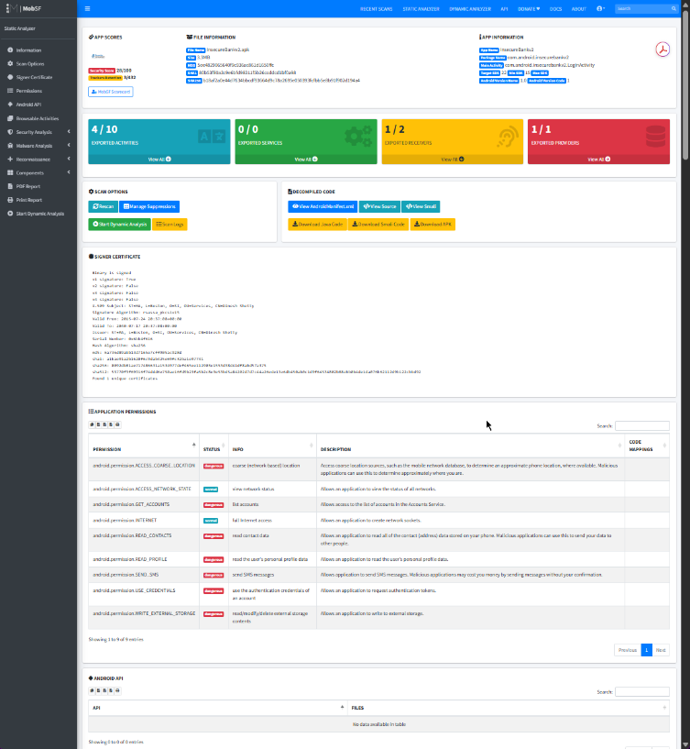
Digging into the specific findings, there are six major issues that jump out across the manifest, the network transport layer, and the actual decompiled code. First off, the app requests the SEND_SMS permission, which is incredibly shady for a banking app and basically invites malware to intercept two-factor authentication codes. On top of that, the Android manifest is a total mess. The developers left android:debuggable="true" in the production build, which rolls out the red carpet for reverse engineers to hook in a debugger and dump live memory. They also left android:allowBackup="true", meaning anyone with a USB cable could pull a full, unencrypted backup of the app’s local data right off the physical phone. If that wasn't enough, the TrackUserContentProvider is fully exported, meaning any random app on the device can query it for backend data without bypassing the login screen.
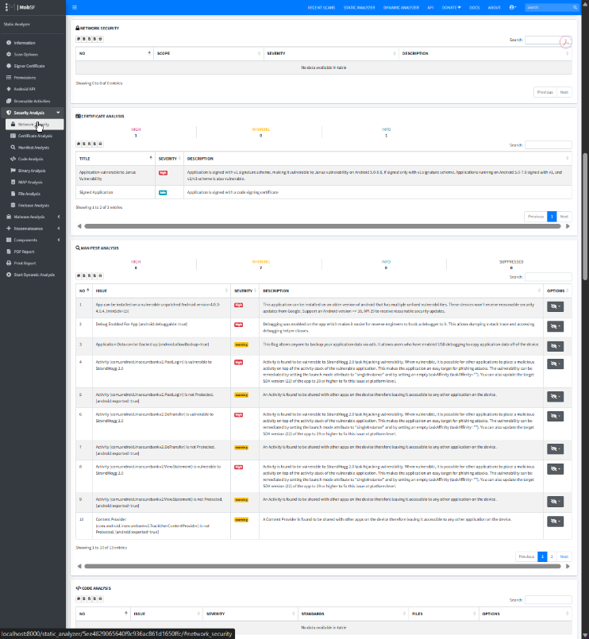
Finding # | MobSF Category | Evidence from Scan | Why This Is a Security Risk | Possible Attacker Impact | Recommended Fix | Your Priority Rating
1 | Manifest / Permissions | android.permission.SEND_SMS | The app requests the explicit ability to send and process SMS data without any legitimate financial justification. | Malware could exploit this to silently intercept dynamic two-factor authentication (2FA) tokens. | Completely remove the SMS permission block from the AndroidManifest.xml layout. | High
2 | Manifest Analysis | Debug Enabled For App [android:debuggable=true] | Leaving the debugging flag active lowers runtime protections, making it incredibly easy to reverse-engineer the logic. | An attacker can hook a live debugger to the process, dump the stack trace, and extract runtime assets. | Set android:debuggable="false" within the production application tag. | High
3 | Manifest Analysis | Application Data can be Backed up [android:allowBackup=true] | This permits the app's local sandbox data to be copied off the physical phone via standard ADB utilities. | If an attacker gets the physical phone, they can extract the app's local storage data using USB debugging. | Flip the configuration parameter to android:allowBackup="false". | Low
4 | File / Manifest Analysis | TrackUserContentProvider is exported (android:exported=true) | This database layer is shared with the rest of the OS, allowing unauthorized inter-process reads. | Malicious apps installed on the same phone can query this provider to siphon out backend data. | Enforce component containment by setting android:exported="false". | Medium
5 | Network / Cert Analysis | Janus Vulnerability (v1 signature scheme) | The app lacks v2/v3 signature protections, leaving its compiled execution block vulnerable to file modifications. | Attackers can inject malicious payload bytes directly into the APK without invalidating the legacy certificate. | Recompile and sign the package utilizing modern v2 and v3 signature schemes. | Medium
6 | Code Analysis | Hardcoded Secrets (e.g., ir8bk+FXNtfVxQq...) | Encryption keys are explicitly hardcoded as plaintext string variables within the app's decompiled Java files. | Anyone who decompiles the app can instantly scrape out these keys to decrypt sensitive local data. | Purge hardcoded keys from the code and utilize the Android Keystore system. | High

The deeper the scan goes, the worse the architecture looks. The app is signed using the outdated v1 signature scheme, leaving it wide open to the Janus vulnerability where an attacker could inject malicious payload bytes directly into the APK without breaking the trusted signature. But the absolute worst finding in the entire scan is buried in the code analysis section. The developers actually hardcoded the cryptographic keys and high-entropy secrets as plaintext strings right inside the Java files. 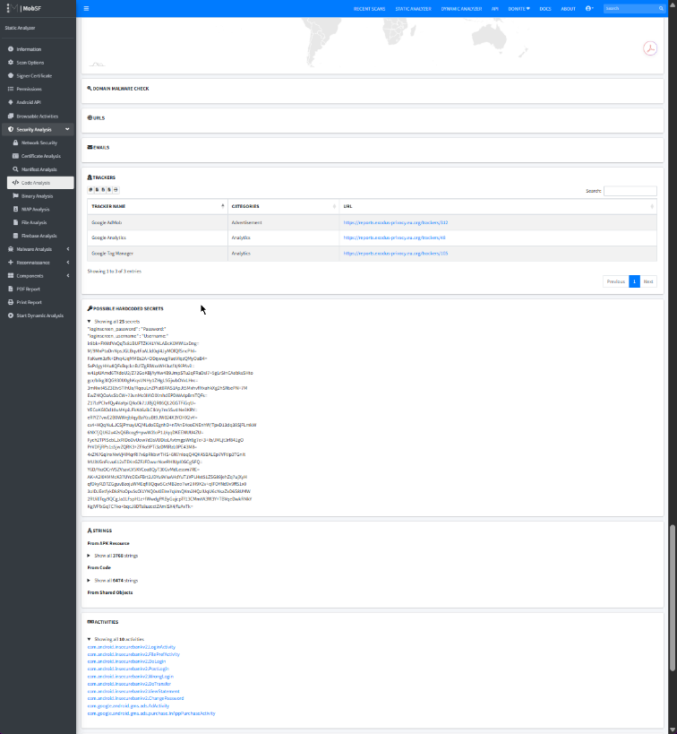
If I were managing this engineering team, we’d be fixing three things immediately: the hardcoded secrets, the debug flag, and the Janus signature flaw. The hardcoded keys are priority number one because they break the entire security foundation out of the box. Anyone can decompile the app in five seconds and grab the key to decrypt user data, making the rest of the app's defenses useless. The debug flag is a close second because it makes reverse engineering way too easy. In fact, out of all the automated alerts, the debug flag is a 100% confirmed issue. Automated scanners can sometimes throw false positives, but because that debug setting is literally printed in black and white inside the compiled XML manifest, there is zero guesswork involved. It’s a guaranteed, provable flaw. The Janus vulnerability is priority three because it allows a bad actor to completely hijack the app's update process with malicious bytecode while flying under the radar of the phone's OS.

To fix this mess, the team needs to make some serious structural and configuration changes. For the hardcoded secrets, the developers need to refactor the Java source code to completely strip out those plaintext strings. They need to replace them by implementing the hardware-backed Android Keystore system to generate and handle encryption keys safely. For the debug issue, they just need to go into the AndroidManifest.xml file and flip the debuggable attribute to false before shipping the release build. Fixing the signature flaw is also a configuration-side fix; whoever handles the build pipeline needs to update the Gradle settings to ensure the app compiles and signs using the modern v2 and v3 APK signature schemes. To actually verify these fixes were successful, the QA team would run a secondary MobSF scan to ensure the entropy scanners no longer flag the keys, attempt to attach a dynamic debugger (jdb) to the live app to ensure it actively rejects the connection, and check the build logs to confirm the v2/v3 signatures report as true.

Looking back at the whole scan, the thing that surprised me the most was actually the StrandHogg task hijacking warnings that lit up the dashboard. It’s crazy to see how leaving old SDK targets allows a completely separate, malicious app to inject fake login screens right over the top of the real banking interface. Out of all the issues to fix, flipping the allow backup flag in the manifest to false would definitely be the easiest, taking about five seconds to close a massive physical data leak without rewriting any code. But the hardcoded secrets definitely create the greatest risk for the users because they compromise everything else.

Ultimately, one major limitation of using a static analysis tool like MobSF is that it only looks at the app while it's sitting still. It reads the code like a text file, but it doesn't tell you how the app actually behaves when it’s running on a phone. If I had more time and tools, the next step would be dynamic analysis. I would hook the emulator up to an interception proxy like Burp Suite, capture the live network traffic, and see if the backend APIs are just as broken as the mobile app itself.

